**Body camera background operation system use instruction**

Step 1:Connect the device to the computer via USB cable, turn on the device. Go back to step 1, double click the “Software” folder, choose the “Body camera background OS.exe”, double click to enter it.

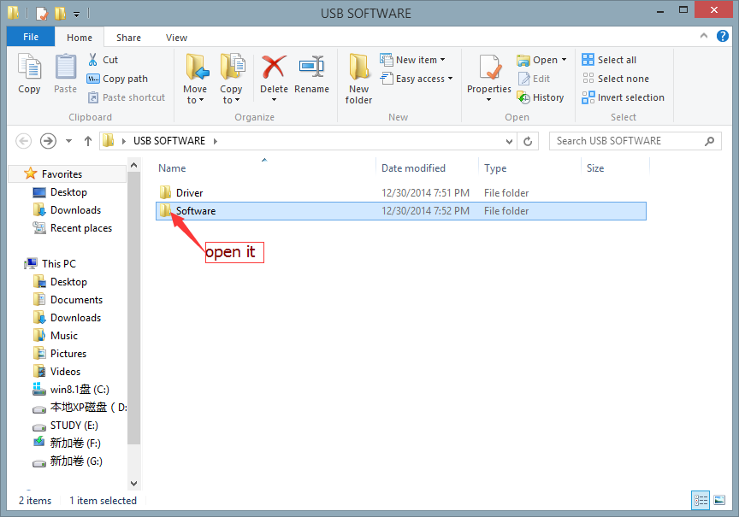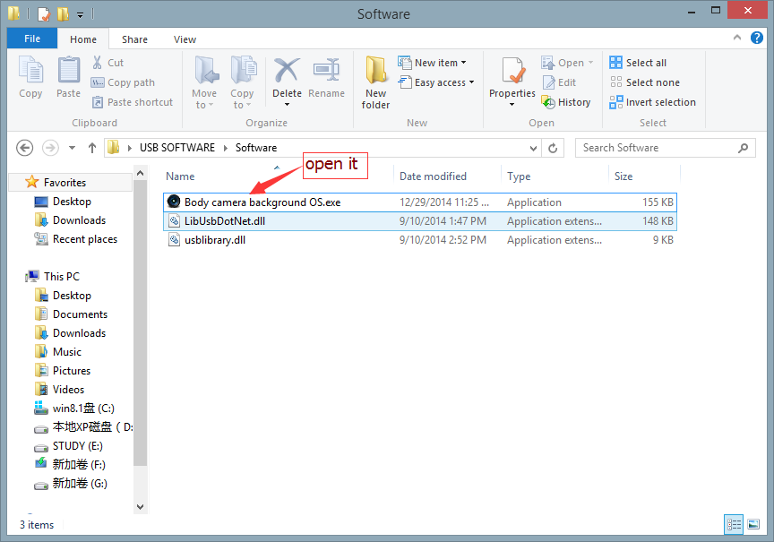

Step 2: Click the “Connect Device”, the computer will remind you that “this device is connected”, click “OK”.

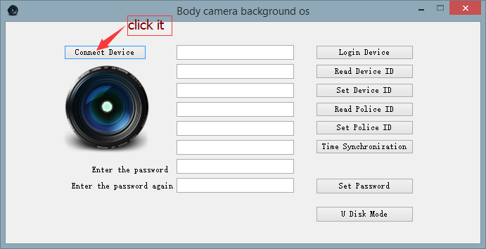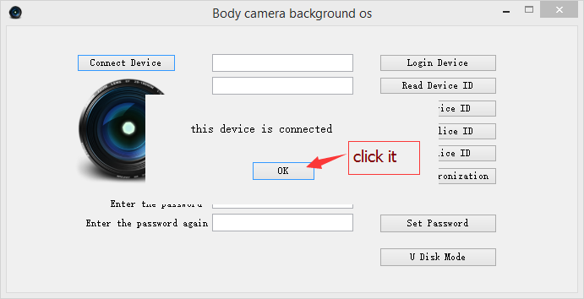

Step 3: Fill in the first blank with the original **password** “**00000000”** (eight zeros)

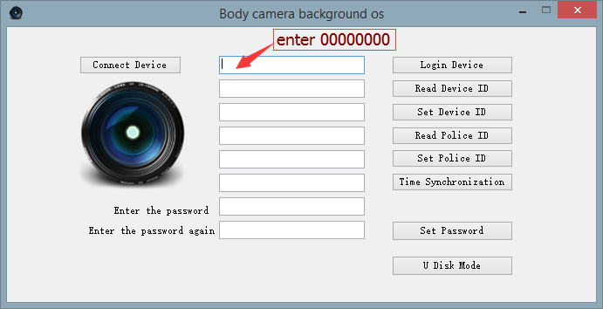

Step 4:Click “Login Device”, the computer will remind you that “The equipment login is successful ”, click “OK”.

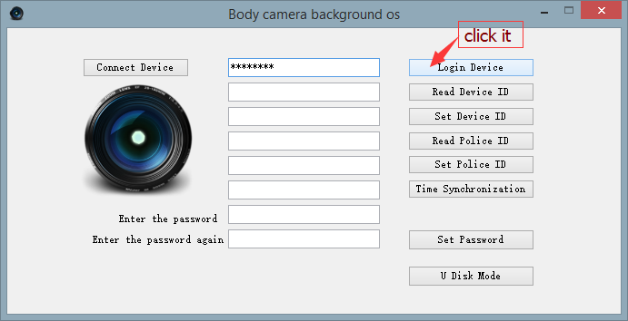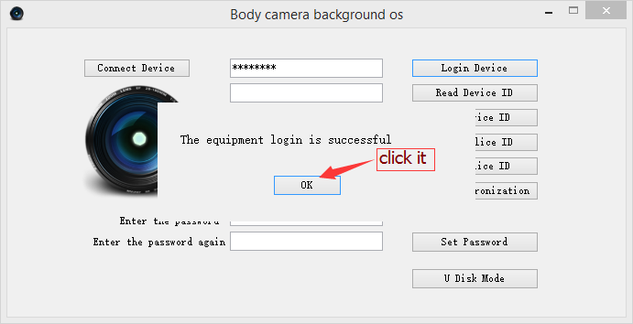

Step 5:Click “Read Device ID”, the computer can read the device ID number. Click “OK”.

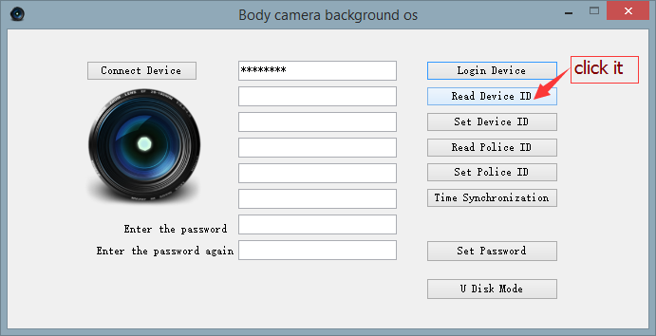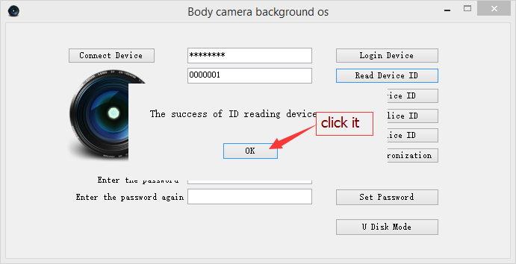

Step 6:You can set the device ID number and the same way to manage the police ID, you can also set new password.

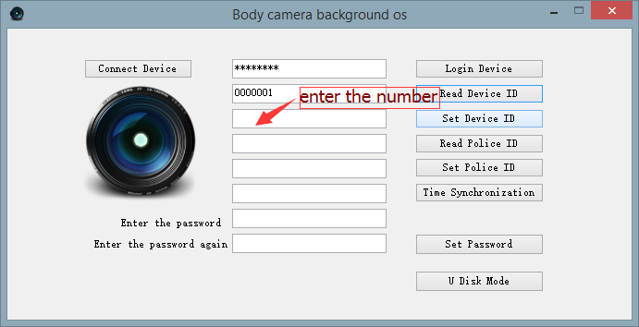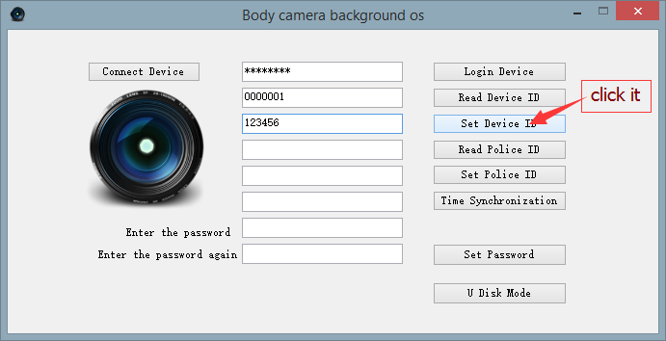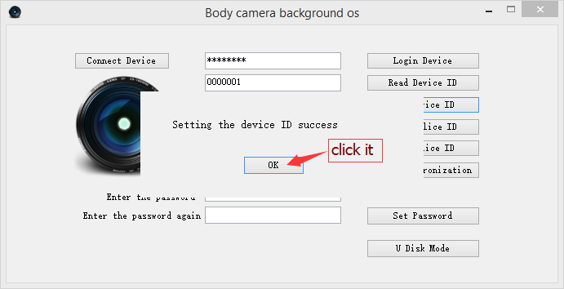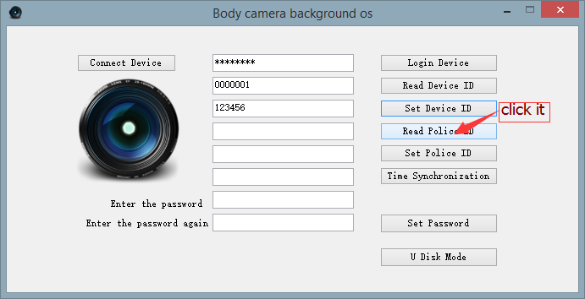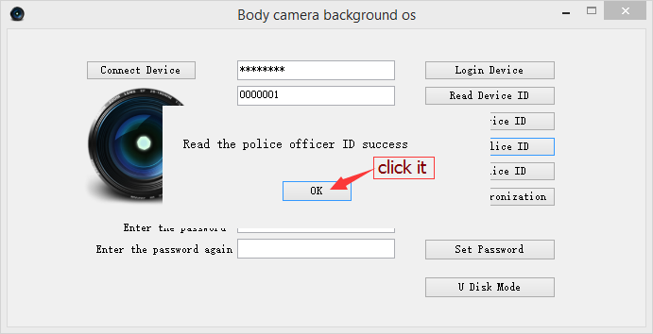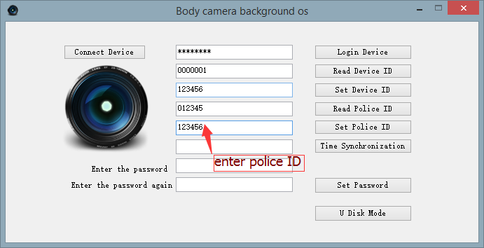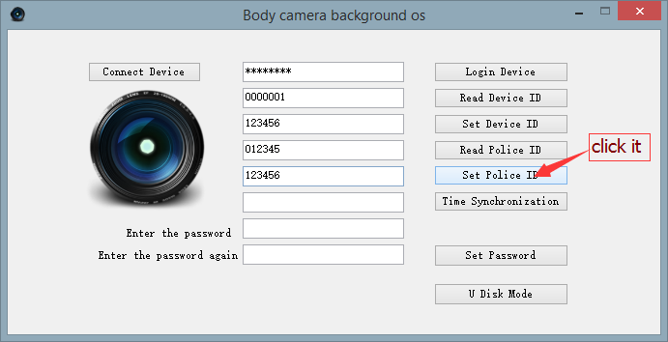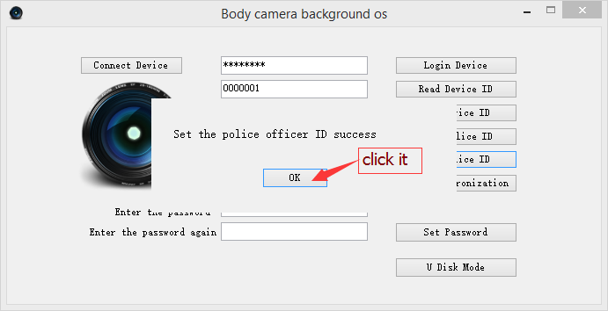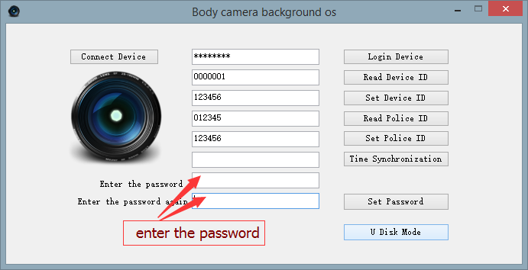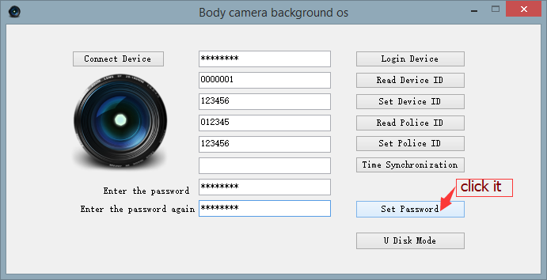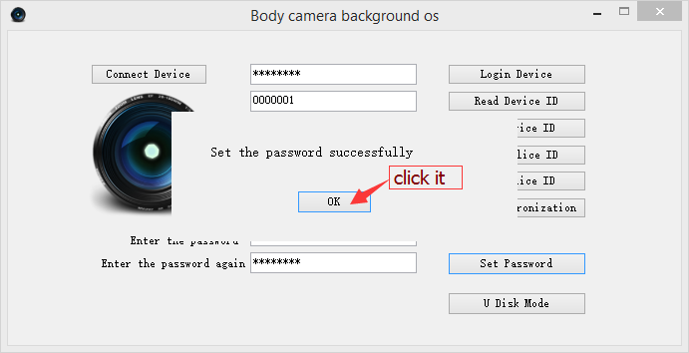

Step 7:Click the “U Disk Mode”, the device will enter the U disk mode, refer to this follow picture.Click “OK”.

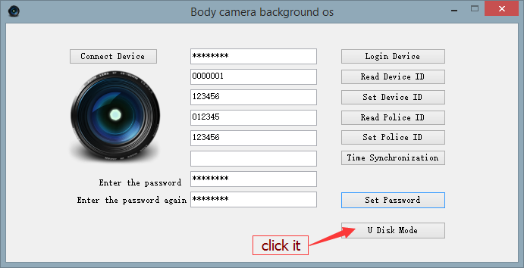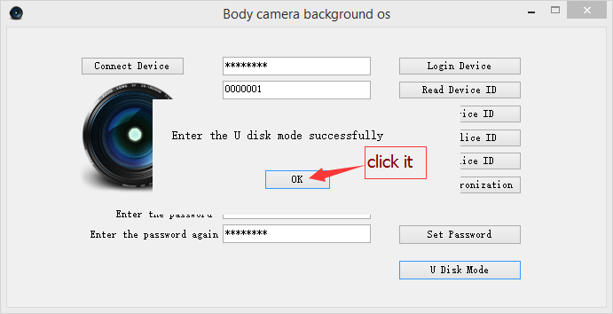

Step 8:After the device has entered the U disk mode, you will find there are two words on the device’s screen “USB connect”, and you can find there is a removable disk in “this PC” which means you can manage the data in the device. You can delete, upload, download, etc. Refer to this picture.

